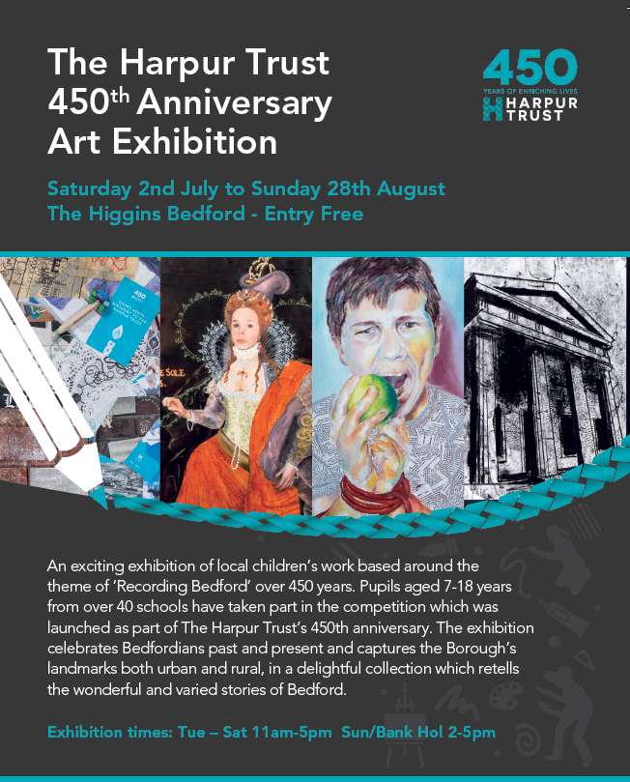



**Harpur Trust 450th Anniversary Art Competition &** **Exhibition**.

Welcome to the Sir William Harpur Gallery where you are about to see an impressive exhibition of children’s work celebrating and recording aspects of Bedford and its people over the past 450 years.

The works you will see here are by children ranging in age from as young as three and four through to eighteen, and have been selected from entries to a competition launched by The Harpur Trust to celebrate its 450th anniversary year.

A total of 44 schools took part in the competition and nearly 1400 entries were received: all of these are available to view online at [www.harpurtrust.org.uk/450th/art-competition](http://www.harpurtrust.org.uk/450th/art-competition)/gallery.

To support the competition, we engaged ten Visiting Artists who delivered a series of workshops to local maintained schools, offering techniques and skills from printmaking to felt-making and collage to illustration. We were also delighted to work with Bedfordshire Archives Service, who inspired many children with stories of local crimes, witch hunts and other historical events. A special thanks to NADFAS for offering additional prizes in our sixth form category.

Throughout our history, we have been supporting and inspiring people within the Borough of Bedford, using the legacy of our founder Sir William Harpur to provide and promote education; to provide relief and help to those who are sick, in hardship or distress; and to provide recreational facilities with a social welfare purpose.

Above all, we want everyone to have pride in their community and to be given opportunities to realise their own potential.

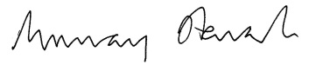With this in mind, we were delighted to create this competition which we hope has inspired local children to explore their artistic talent. We have certainly been inspired by the work they have produced.

**Murray Stewart  
Chairman**

**The Judges**

**Alex Chinneck**   
Internationally revered British artist, sculptor and designer. Alex grew up in Bedford and was educated at Bedford Modern School.

**Suresh Dutt MRBS**   
Sculptor and Harpur Trust grant recipient.

**Dawn Giles**   
Artist and Director of &Co (Formerly Bedford Creative Arts).

**Tom Perrett.**   
Head of The Higgins Bedford.

**A special thanks to our NADFAS Judges who offered additional prizes for the sixth form category.**

Laurie Jones and Hannah Birkett

**The Competition brief**

The theme of the competition was **‘Recording Bedford’** and entrants were required to create an imaginative artwork reflecting an aspect of Bedford or Bedford life at some point during the Harpur Trust’s 450 year existence. Entrants could look at the life of Sir William Harpur, focus on particular moments in time during the Trust’s history, portray well-known individuals connected to the Trust or other famous Bedfordians, look at buildings and architectural features associated with the trust, or other well-known Bedford landmarks.

**EARLY YEARS (3-4 years)**

The main competition was aimed at 7-18 year olds, but in order to engage younger children we launched a second competition for Early Years and Key Stage 1. We received a great response and all work is on display in our online gallery.

For the Early Years category, participants were asked to produce a collaborative piece involving a group or class of children.

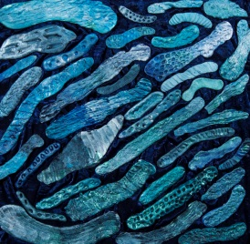

**1st Place**

**Castle Newnham School**

“The children talked about walking along the beautiful Bedford Embankment. They thought of words to describe the different shapes and patterns reflected in the river; snaky, spotty, zigzaggy, stripy, shimmery, blue. We then used modelling clay to create flowing shapes and then chose different tools to make patterns”.

*Mrs Douglas Teacher*

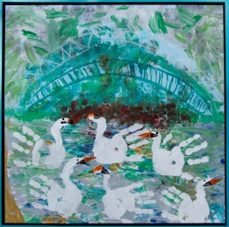

**2nd Place**

**Kempston Rural Lower School**

“As Kempston Rural Lower School are proud of our school's swam emblem and Bedford is proud of its river, Cygnets and Goslings classes have portrayed swans on the River Great Ouse, in the style of Monet. They enjoy printing with fingers, hands, sponges and potatoes, using acrylic and ready mixed paint”.

*Ann Carson Teacher*

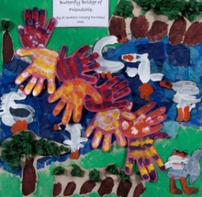

**3rd Place**

**St Andrews School**

St Andrews School’s early years team used the children’s handprints to produce the bridge of friendship for this colourful piece.

*Louise Dampsaj and Jo Mills Teachers*

**KEY STAGE 1 (4-7 years)**

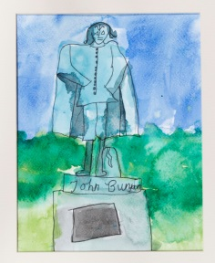

**1st Place**

**Pilgrims Pre-Preparatory School**

**Tom Ulvert**

*“It's clearly done by a budding artist and confidence is more important than anything at that age. They must continue to draw and paint.”*

*Alex Chinneck*

Castle Newnham School focussed on what makes Bedford a special place. Russell Park is somewhere the children all enjoy spending time in so they came up with ideas of what they like most about the park.

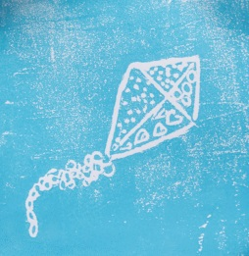

**2nd Place**

**Castle Newnham School**

**Serena Ormerod**

*“This is beautiful. Delicate in colour and sketching.”*

*Alex Chinneck*

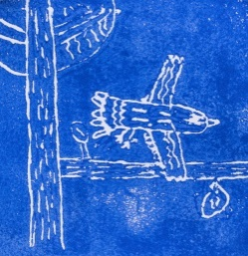**3rd Place**

**Castle Newnham School**

**Isaac Kores**

*“Full of personality and movement”.*

*Alex Chinneck*

**CATEGORY 1 (7-11 years)**

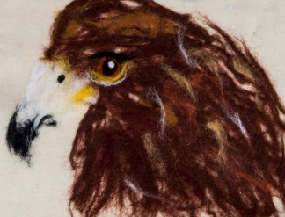**1st Place**

**Livingstone Primary School**

**Tyliyah Sadiq-Williams**

Livingstone School focussed on the Eagles of Bedford, a symbol used by so many schools and organisations within the town. Artist Anne Marie-Stijelja helped the children to make their own felt.

Visiting artist: Anne-Marie Stijelja

*“Textural and incredibly lifelike. A lot of personality in the eyes.”*

*Alex Chinneck*

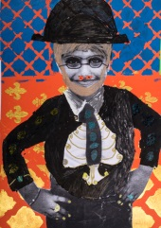

**2nd Place**

**Great Denham Primary School**

**Guraj Anand**

The children at Great Denham worked with artist Tiffany Logan whose idea for the competition was to get the children to produce self-portraits in a historical context.

Visiting artist: Tiffany Logan

*“A fun subject, fun colours and a brilliant collage”.*

*Alex Chinneck*

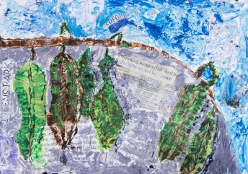**3rd Place**

**Queens Park Academy**

**Assim Mahmood**

This piece is called ‘Autumn Decoration’.

*“Clearly a lot of work and a lot of talent.”*

*Alex Chinneck*

**CATEGORY 2 (11-14 years)**

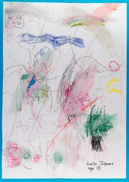**1st Place**

**St John’s Special School & College**

**Laila Johnson**

The children worked on historic and current maps of Bedford and then created their own version which included their school, home and favourite places. This piece was created using watercolour pencils.

Visiting Artist: Livi Gosling

*“Full of energy and optimism.”*

*Alex Chinneck*

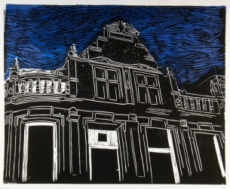

**2nd Place**

**Bedford School**

**Henry Williams**

*“Technically fantastic”*

*Alex Chinneck*

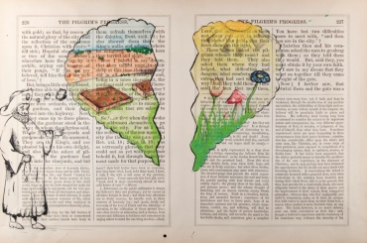**3rd Place**

**Lincroft School**

**Cameron Campbell**

An illustration of pages from John Bunyan’s Pilgrim’s Progress.  
Visiting artist: Katy Dynes

*“Exceptional illustration. Whatever you do, keep drawing.”*

*Alex Chinneck*

**CATEGORY 3 (14-16 years)**

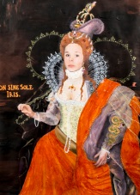

**1st Place**

**Wootton Upper School**

**Katie Lansbury**

**Harpurs Trust Anniversary 450th Competition.**

Katie was inspired by a portrait of Queen Elizabeth I in a portrait by Issac Oliver. The painting portrait was produced 450 years ago when the Harpur Trust charity was founded.

Visiting artist: Tiffany Logan

*“Playful, technically accomplished and innovative.”*

*Alex Chinneck*

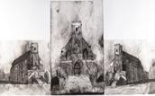

**2nd Place**

**Bedford School**

**Ignatius Ip**

Bedford School Chapel

*“Technically exceptional. Brilliantly moody”*

*Alex Chinneck*

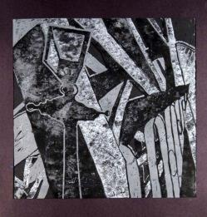

**3rd Place**

**Bedford Girls’ School**

**Natasha Howard**

*“Tonally and texturally very interesting. A fantastic piece of work.”*

*Alex Chinneck*

**CATEGORY 4 (16-18 years)**

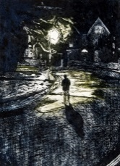

**1st Place**

**Bedford School**

**Daniel Zhou**

*“Technically exquisite. Incredible mark making. It transcends just being visual and becomes experiential and brilliantly moody.”*

*Alex Chinneck*

**NADFAS 1st Prize**

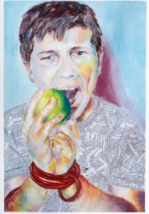**2nd Place**

**Sharnbrook Upper School**

**Georgia Crow**

This piece has been inspired by the story of Robert Toll, accused of feloniously cutting and damaging 11 cherry trees, a mulberry tree, sundry pear trees and other trees, the value amounting to £50. He had taken revenge on the garden of his landlord, Mr Tucker, as he had been evicted. This piece illustrates Toll’s disrespect and vandalism. The eating of the apple demonstrating defiance.

Visiting artist: Sally Annett

*“A strong interpretation of a historic narrative - not too obvious.*

*A wonderful palette and brilliant use of mark making.“*

*Alex Chinneck*

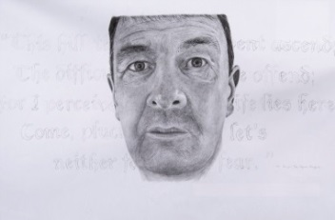**3rd Place**

**Sharnbrook Upper School**

**Richard Burke**

This a contemporary portrait representing the steadfast character of John Bunyan.

Visiting artist: Sally Annett

*“Clearly a brilliant draughtsman; he must continue drawing.”*

*Alex Chinneck*

*Additional NADFAS Prizes:* ***2nd place*** *Claire Merriman Year 12 Sharnbrook School.* ***3rd Place*** *Charles Cooper Year 12 Sharnbrook School,* ***Special prize*** *awarded to Ridgeway School for their collaborative piece.* ***Commendations*** *awarded to Tom Rainbow Year 12, Bedford School and Katrina Norton, Year 12, Sharnbrook School*

**Our Visiting Artists**

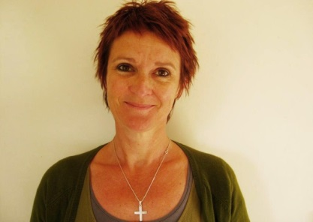

**Deirdre Porter-Hanson**

I have over 30 years teaching experience working with both adults and children of all ages and abilities. My practice is diverse but I mainly work in 2D. My drawings are generally observational whilst my paintings and collages are more abstract exploring thoughts on environment, geology, and a sense of place.

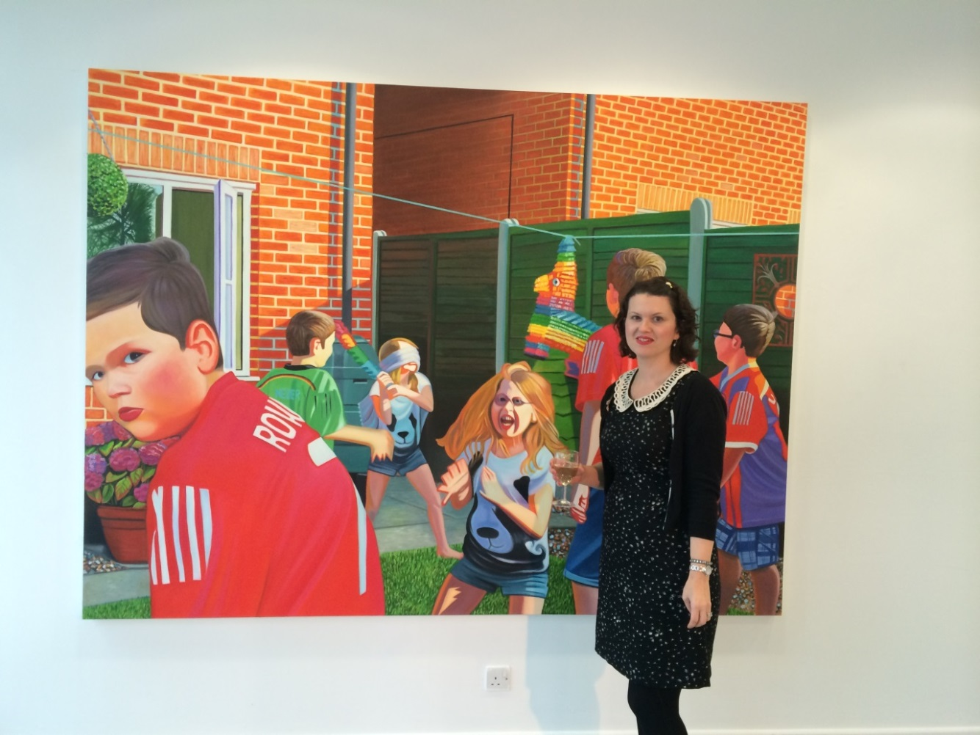

**Emma Richardson**

My primary means of creative expression is painting and drawing. My work explores the uncanny and the vulnerable, often inspired by director David Lynch’s work with his dystopian and surreal vision of suburbia. I was a selected artist for Platform 2015 and was shortlisted for Bloomberg New Contemporaries 2016.

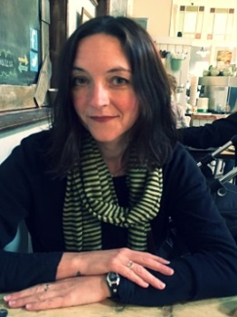**Lyndsay Chessum**

Within my own art practice, I am a painter and illustrator, and my preferred medium is acrylic on canvas. Subject matter, influences and style has varied and grown over the years, but I have always produced figurative work.



**Sally Annett**Multi-media artist, produce and researcher based in the UK. Annett is interested in collaboration and postdisciplinary practice: material artworks extend to painting, printmaking, installation, photography, dance, performance, intervention and film. She is best known for co-curatorial roles developing public art events with Arts Council England (ACE).

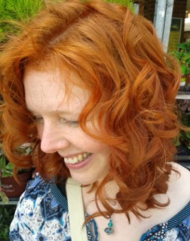

**Katie Dynes**

My artwork is mostly illustration based.....I love working with and designing 'characters', setting the scene, experimenting with different materials and always telling a story.

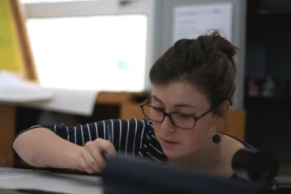**Livi Gosling**I’m an illustrator and commercial artist. I specialise in illustrated maps, food & drink illustration and editorials. I use monochrome indian ink in all of my work and colour my pieces digitally. I use photoshop to arrange my illustrations as it makes everything a lot easier to move around with client feedback.

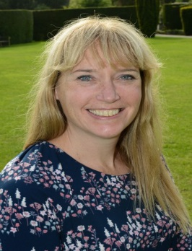

**Anne-Marie Stijelja**I would describe my art work as a ‘mash-up’ of all media.  I enjoy mixing textiles with sculpture, print, collage and paint. I am inspired by working with recycled or found objects.

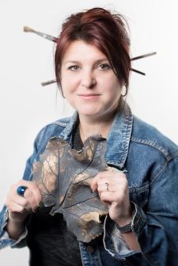

**Amanda Silk**

My own creative medium predominantly involves ceramics, glass and drawing, my work is expressive; I like to use a wide variety of materials and mixed media to communicate the character and personalities of others, through sculpture and illustration. I also incorporate inspiration by the human form and the natural world.

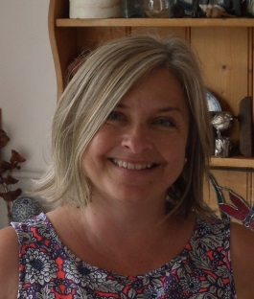

**Tiffany Logan**

I’m a mixed media Artist who loves the accidental and haphazard things that occur within the act of painting. I like to work in a semi abstract way and the process is important to me - I tend to create masses of detail and then blot out parts and then repeat the process. I also love the simplicity of children’s drawings and often aim to capture some of that freshness in my work.

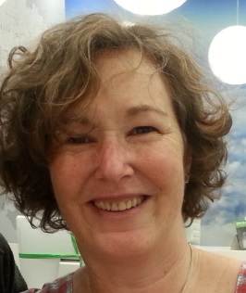

**Susan Erskine-Jones**

My mixed media work uses the cross over between printmaking and painting. I use palette knives, rollers, rags and occasionally paint brushes. I evoke the feeling or memory of a place as I experienced it through the use of my layering of paint and collage onto paper.

**With thanks to:**

**The Higgins Bedford**

**NADFAS**

**Art Centre & Gallery**

**& CO (Bedford Creative Arts)**

**Bedfordshire & Luton Archives Service**

**Wallace Brown Picture Framing Shop**

**Bedford College Photography Department**

