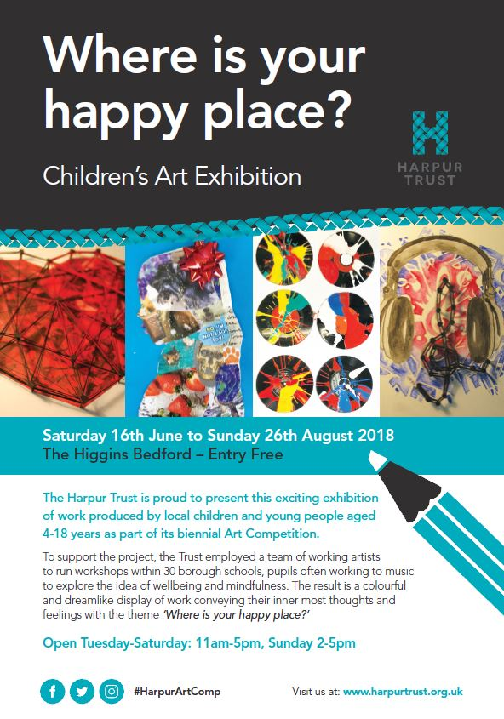

An exhibition of work responding to The Harpur Trust’s biennial competition for local pupils aged 4-18 years

### 

**THE HARPUR TRUST 2018 ART COMPETITION & EXHIBITION - WHERE IS YOUR HAPPY PLACE?**

Following the success of The Harpur Trust’s 450th Anniversary Art competition in 2016, we are delighted once again to have been able to run a competition for Bedford Borough pupils aged between 4 and 18 years of age.

As part of the competition, we commissioned a team of professional local artists to go out into state schools to deliver workshops over a 6 month period.

Prizes were awarded to both the winning pupils in each category, and a further prize has been donated to their schools to be used for purchasing art equipment.

The 100 or so pieces of work exhibited here at The Higgins Bedford were selected by our judges and provide a wonderful snapshot of the competition, but all of the submissions can be viewed on an online gallery.

[**www.harpurtrust.org.uk/art-competition/gallery**](http://www.harpurtrust.org.uk/art-competition/gallery)

We hope you enjoy the exhibition.

**OUR JUDGES**

**Tom Perrett** is Manager for Libraries & Culture for Bedford Borough Council, which includes responsibility as Curator for The Higgins Bedford, as well as for the Borough’s Library Service and Bedford Corn Exchange. He led on the redevelopment of the art gallery and museum, which aims to be a community hub that works both with and for local people. He is delighted that artworks made by local children and young people can be displayed on the same walls that are used to hang pictures by Turner, Picasso and a whole host of famous artists represented in The Higgins’ collections.

**Kayte Judge** is The Youth Participation Producer at Bedford Creative Arts. She runs The Culture Challenge supporting schools to work with the creative and cultural sector. With an MSc in Managing Business Creativity and Innovation she cut her teeth in the arts through her community work as a social entrepreneur, running RSA funded grass roots arts projects in empty shops in Bedford. Kayte believes that all people should feel an outrageous sense of entitlement to the arts and encourages people to experience the full range of cultural activities available to them, even when it scares them a little.

### Hannah Birkett studied fine art and creative writing at Lancaster University, and after graduating went on to study fine art at the Royal Academy Schools.  Her practice incorporates sculpture and painting, with a strong foundation in drawing.  She continues to exhibit both nationally and internationally, including Mostyn Open Exhibition (2014), the Royal Academy, Hack the Barbican, and Wisnicz Castle, Poland.  Hannah teaches art and design to both Foundation and BA students in the UK, contributing to the University of Bedfordshire, City and Guilds and University Centre Hastings.

**THE COMPETITION BRIEF**

This year, the underlying theme of the competition was wellbeing and mindfulness. We asked entrants to produce an imaginative piece of work depicting the happiest place in their mind. This could be a real place or a completely imaginary world. It could be a happy memory which they like to return to again and again, or they could portray themselves in an activity which makes them happy. A happy place might also depict other people; friends, family, the animal world, or even a scene from a much loved book or film.

|  |  |
| --- | --- |
| **OUR VISITING ARTISTS** | |
| **cid:76954B48-7F86-4C94-ACC5-FBE48B624E27** | **Deirdre Porter-Hanson** I have over 30 years teaching experience working with both adults and children of all ages and abilities. My practice is diverse but I mainly work in 2D. My drawings are generally observational whilst my paintings and collages are more abstract exploring thoughts on environment, geology, and a sense of place. |
|  | **Anne-Marie Stijelja**  I would describe my art work as a ‘mash-up’ of all media.  I enjoy mixing textiles with sculpture, print, collage and paint. I am inspired by working with recycled or found objects. |
| **C:\Users\selam\AppData\Local\Microsoft\Windows\Temporary Internet Files\Content.Outlook\4BV5XKKO\EmmaRichardson2.JPG** | **Emma Richardson** My primary means of creative expression is painting and drawing. My work explores the uncanny and the vulnerable, often inspired by director David Lynch’s work with his dystopian and surreal vision of suburbia. I was a selected artist for Platform 2015 and was shortlisted for Bloomberg New Contemporaries 2016. |
|  | **Amanda Silk** My own creative medium predominantly involves ceramics, glass and drawing, my work is expressive; I like to use a wide variety of materials and mixed media to communicate the character and personalities of others, through sculpture and illustration. I also incorporate inspiration by the human form and the natural world. |
|  | **Susan Erskine-Jones** My mixed media work uses the cross over between printmaking and painting. I use palette knives, rollers, rags and occasionally paint brushes. I evoke the feeling or memory of a place as I experienced it through the use of my layering of paint and collage onto paper. |

|  |  |  |
| --- | --- | --- |
| **CATEGORY 1 (4-7 years)** | |  |
|  | 1st PlacePutnoe Primary School*Demilade Yusuf*****Space Rocket**** “This is my happy place because I like going on rockets. I like shiny stars. I like the moon because it is a circle. I painted my background grey and black then coloured my rockets in pastels and stuck it on”. | |
|  |  | |
|  | 2nd PlacePutnoe Primary School*Brandon*  **Firework Noise** “Fireworks are my happy place because they make noise. I used glitter. The colours are yellow, blue, orange and pink. I like the colours fireworks make”. | |
|  |  | |
|  | 3rd PlaceBrickhill Primary School*Laura Dolkiewicz* **Unicorn** “A unicorn in a field with pretty flowers and some ponds”.  Brickhill Primary’s artist workshop had a strong music theme, the unicorn has been produced on a 7” vinyl, and sheet music featuring happy songs were incorporated within the design. | |
|  |  | |
|  | CommendationSt John’s Special School & College*Reuben*  The judges loved this piece, not least because Reuben refers to his friend Jasmine as his best friend and in the picture below, she appears to be replying, naming him as one of her happy places. | |
|  |  | |
|  | CommendationSt John’s Special School & College*Jasmine* Jasmine likes party music, the colour pink, watching Peppa Pig and cuddling her mum. Her best friend is Reuben. | |
|  |  | |
|  | CommendationPilgrims Pre-Preparatory School*Luke*  Luke’s lego inspired picture clearly shows how he enjoys spending his time. We loved this bright, colourful piece. | |

|  |  |
| --- | --- |
| **CATEGORY 2 (7-11 years)** |  |
|  | 1st PlaceLivingstone Primary School*Safi Barry-Hill* “I chose the dragon as my spirit animal because dragons are really cool and they can fly which is amazing. Dragons are incredibly strong and can breathe fire. They are also good fighters!” |
|  |  |
|  | 2nd PlaceHarrold Primary Academy*Joshua*  “Me in Gran Canaria having fun with my family”. |
|  |  |
|  | 3rd PlaceBedford Preparatory School*Will*  **Blakeney in Norfolk** “I used acrylic paint on canvas. I’m most proud of the sunset and the colours I mixed. It took me two weeks to complete. I decided to collage words on the painting so it would show why Blakeney is my happy place”. |
|  |  |
|  | CommendationPutnoe Primary School*Dane*  **Chomp** “I am happiest when I play with my pet hamster Chomp. When I have a bad day at school, I like to play with Chomp when I get home, and he makes me feel better. I decided to colour Chomp this because all of the colour makes everything as one”. |
|  |  |
|  | CommendationIndividual entrant*Stanley*  **The Stick Conquest** “My name is Stanley, my artwork is about the Spanish Conquest in reverse. But with high tech machinery and many cunning devices”. |
|  |  |
|  | CommendationShortstown Primary School*Zuzanna Kosiewiz* Felted artwork. The pupils at Shortstown produced their own felt for these colourful designs, under the direction of our artist Anne-Marie Stijelja. |
|  |  |
|  | CommendationHarrold Primary Academy*Keiran*  “I love reading because reading different stories opens a whole new world. My favourite special place is reading a book”. |
|  |  |
|  | CommendationHarrold Primary Academy*Isabella Rice* “Every time I’m sad I picture my mum cuddling me. If I win all credit to my mum for making me smile”. |

|  |  |
| --- | --- |
| **CATEGORY 3 (11-14 years)** |  |
|  | 1st PlaceBedford Preparatory School*John*  “At work with my pastels Art makes me happy. I’ve used oil pastels and the scraffito technique and I am particularly proud of the skin. The background is orange so the skin tones enhance. I’ve applied complimentary and contrasting colours for a vibrant, warm feel”. |
|  |  |
|  | 2nd PlaceGoldington Academy*Muhktar*  Ceramic Hamsa Hand.  “The Hamsa Hand is an ancient Middle Eastern amulet symbolizing the Hand of God. In all faiths it is a protective sign. It brings its owner happiness, luck, health, and good fortune”. Wikipedia |
|  |  |
|  | 3rd PlaceSharnbrook Academy*Dylan*  Our visiting artist Emma Richardson encouraged pupils to put themselves at the heart of their composition which was created from a combination of photographs, drawing and collage materials. |

|  |  |  |
| --- | --- | --- |
| **CATEGORY 4 (14-16 years)** |  | |
| **\\harpursvr1\Photo Library\Community events\Art Comp 2017-2018\Category 4\C4WOOUS10_2.jpg** | 1st PlaceWootton Upper School*Ruby Collins* “Nature is my happy place because it gives you an unimaginable feeling of freedom and self-expression. I love the changes through the seasons, and this is what has inspired me to create this dress. As it is reversible is shows off the different sides of nature. The darker side of Autumn and Winter, and the lighter side of Spring and Summer”. | |
|  | |  |
|  | 2nd PlaceWootton Upper School*Katie Cooper* Katie uses swimming to escape from the stresses of her exams.  “I have always loved to swim, since the age of 5.  I would go most weekends just to a local pool but this was taken in the freezing river water of Dordogne”. | |
|  | |  |
|  | 3rd PlaceWootton Upper School*Meghan Clarke*  “I chose a book due to the fact books are a sort of comfort to me as I spend the majority of my free time reading. The experience was something new for me that I enjoyed and would participate in again”. | |
|  | |  |
|  | CommendationWootton Upper School*Danielle Cutts* “When I painted this I was at my most happiest because painting is my happy place. It’s my escape”. | |

### OUR THANKS TO:

### The Higgins Bedford

### Bedford Creative Arts

### The Arts society North Bedfordshire

### Wallis Brown Studios

### The Art Centre and Gallery

### Higgins Pantry

### Bedford College Photography Students & Staff

### Our judges and our team of Artists

### The Art teachers at participating schools

### And finally, a very special thank you to all the children who took part.

[**www.harpurtrust.org.uk/art-competition/gallery**](http://www.harpurtrust.org.uk/art-competition/gallery)